**Bead Based RNA SPRI Bead Extraction Method with use on KingFisher Systems**

Tillie J. Dunham*, Shaun T. Cross* & Mark D. Stenglein

**Introduction**

Here we established a magnetic bead based RNA extraction protocol that can be used on the Thermo KingFisher system. We compared our extraction method to the Zymo Direct-zol miniprep kit. We found our extraction method to be comparable to that of the Zymo kit and far more cost effective. It also saves time by using the KingFisher, each 96 well extraction takes 20 minutes to run on the KingFisher after setting up.

Zymo Direct-zol miniprep kit

(<https://www.zymoresearch.com/products/direct-zol-rna-miniprep-kits>)

**General Workflow**

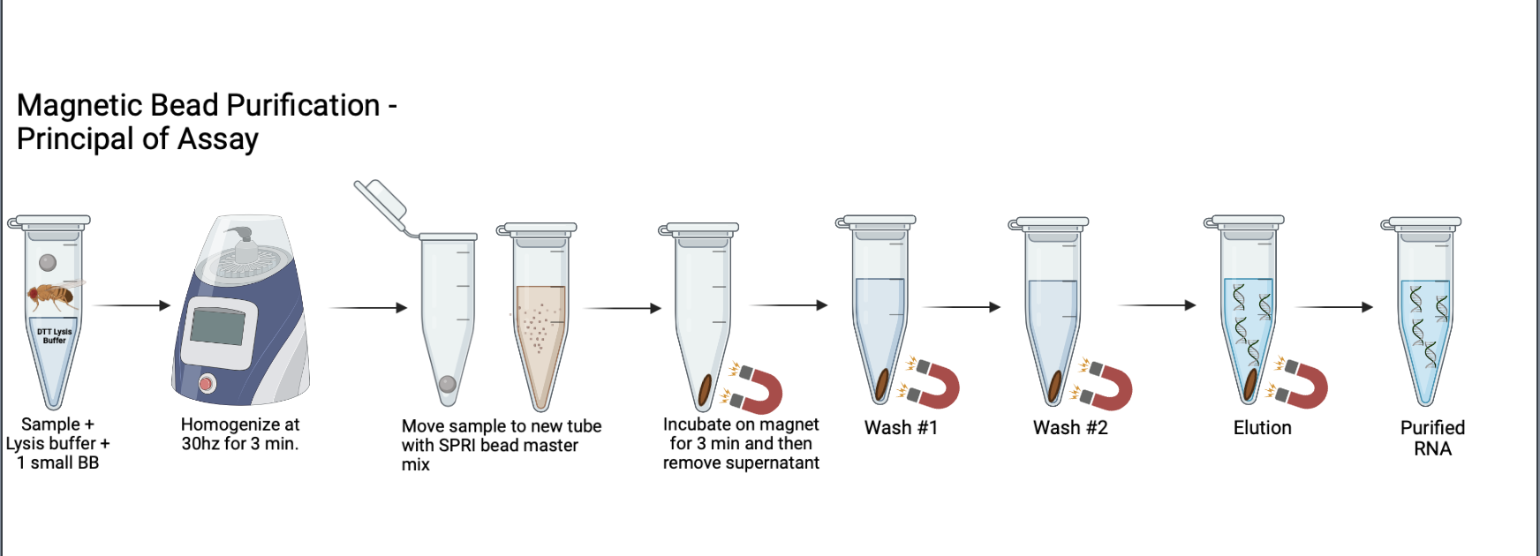

**Figure 1** - General workflow of Magnetic Bead Purification

The general workflow of this protocol starts by homogenizing and lysis your samples in lysis buffer with a small steel BB. You then mix your sample with the master mix containing RNA SPRI beads where your RNA/DNA in the sample will bind to the beads. You can then capture the beads and RNA using a magnet and perform washes to remove any impurities from the sample. After the wash steps you elute in water and have purified RNA.

**Results**

***Drosophila Melanogaster***

* KingFisher vs Directzol: Qubit (RNA), Nanodrop, qRT-PCR, Tapestation (RNA)

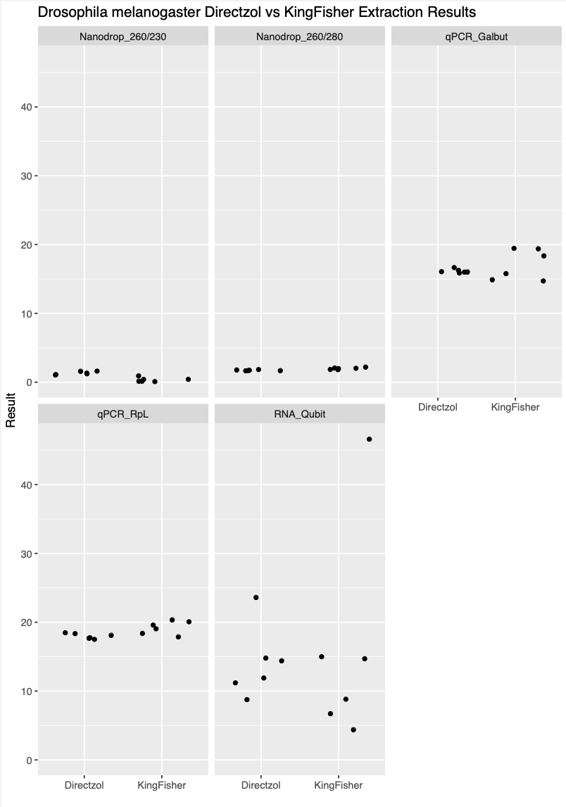

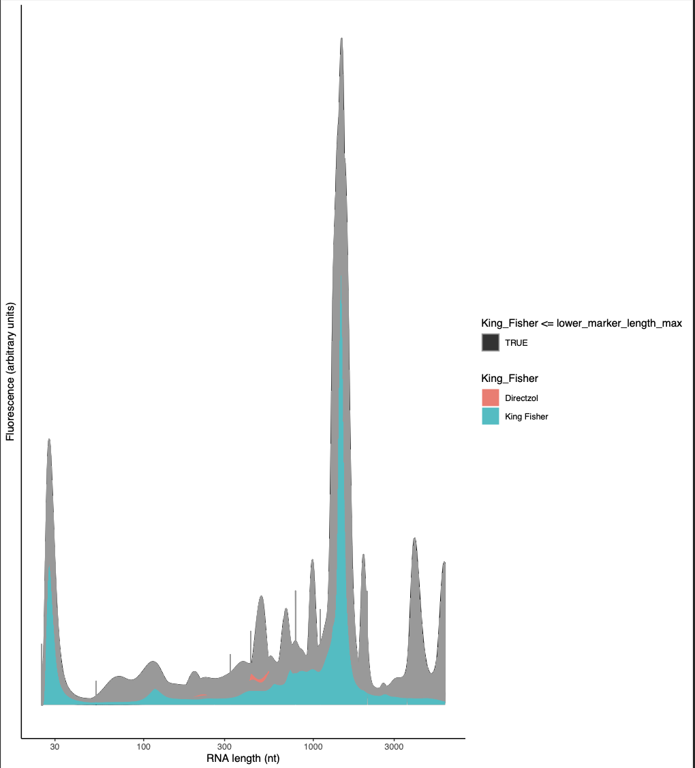

** Need to change legend to match colors on graph!

***Aedes Aegypti***

* KingFisher vs Directzol: Qubit (RNA), Nanodrop, qRT-PCR

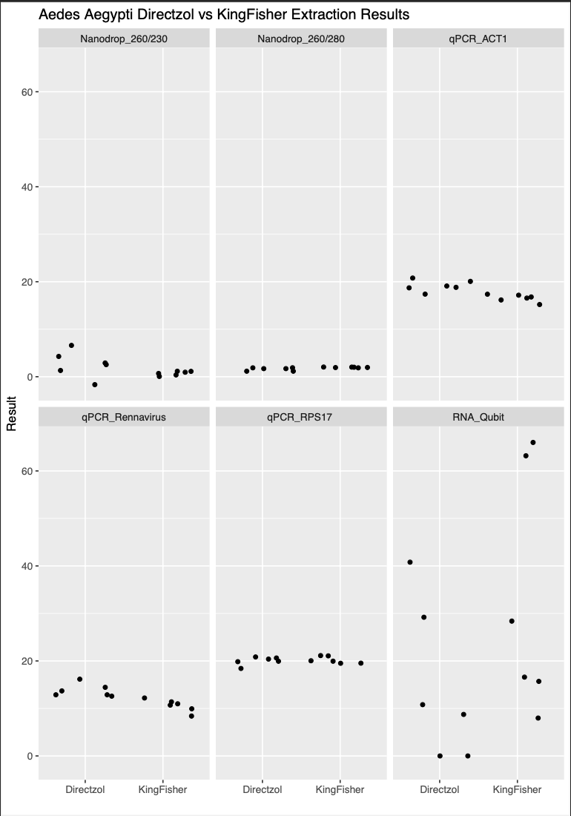

**Cell Lines**

* KingFisher vs Directzol: Qubit (RNA), Nanodrop, qRT-PCR

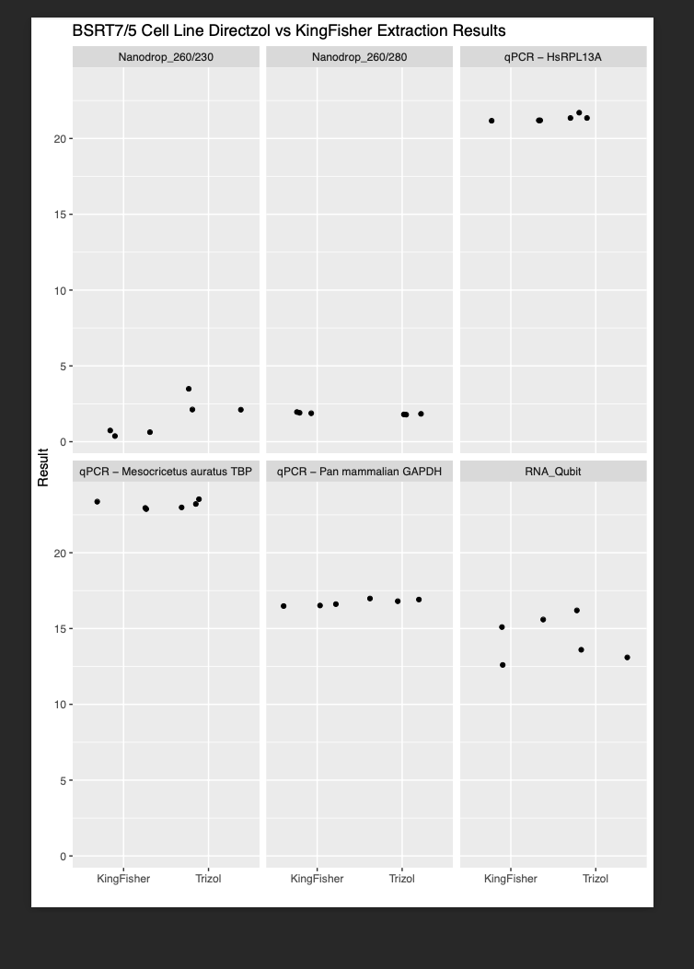

**Samples Frozen in Lysis Buffer**

* KingFisher vs Directzol: Qubit (RNA), Nanodrop, qRT-PCR

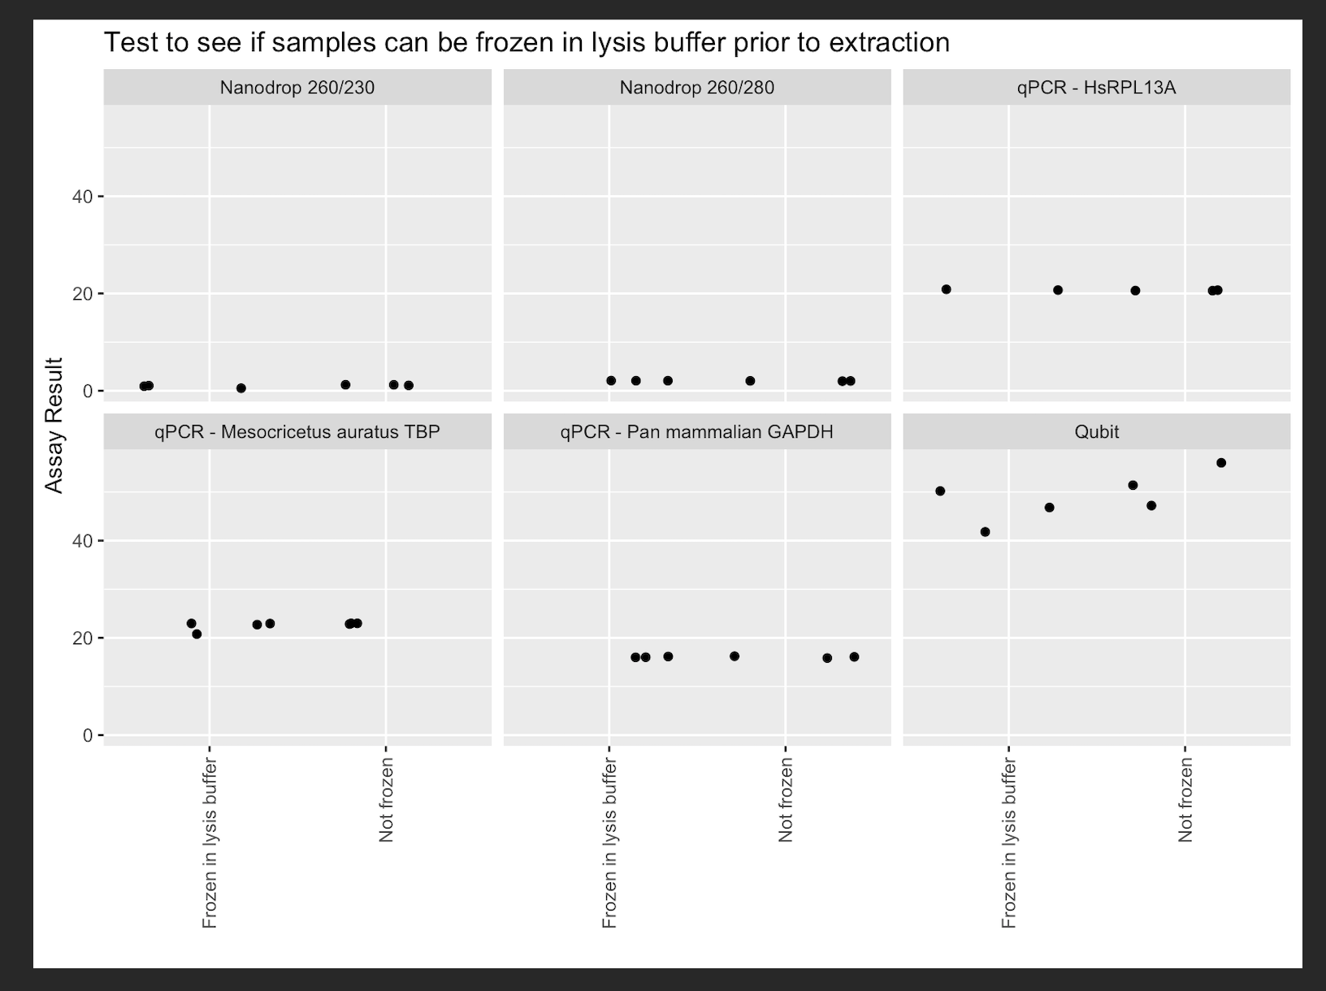

**Protocol on KingFisher**

**Protocol by Hand with DNase**